Sweet Dessert
Ivancho and his girlfriend are throwing a party. She plans to cook her favorite dessert. She asks Ivancho to buy the needed products. The number of desserts depends on how many people will be coming. She can prepare the dessert in portions of 6. If there are 5 guests coming, she will still cook 6 portions, for 10 guests – will cook 12. The products for the dessert are bananas, eggs and berries. For a set of 6 she needs 2 bananas, 4 eggs and 0.2 kilos berries.
You will be given the amount of money Ivancho has, the number of guests and the prices of the products. You have to help Ivancho calculate if the cash he has is enough to buy all of the products, or how much more money he needs.
Input
The input data should be read from the console. It will consist of exactly 5 lines:
The amount of cash Ivancho has – floating-point number in range [0.00…1,000,000,000.00]
The number of guests – integer in range [0…1,000,000,000]
The price of bananas for a single unit – floating-point number in range [0.00…1,000.00]
The price of eggs for a single unit – floating-point number in range [0.00…1,000.00]
The price of berries for a kilo – floating-point number in range [0.00…1,000.00]
The input data will always be valid and in the format described. There is no need to check it explicitly.
Output
The output should be printed on the console.
If the calculated price of the products is less or equal to the money Ivancho has:
“Ivancho has enough money - it would cost {the cost of the products}lv.”
If the calculated price of the products is more than the money Ivancho has:
“Ivancho will have to withdraw money - he will need {neededMoney}lv more.”
All prices must be rounded to two digits after the decimal point.
Examples
Input | Output | Comments
10  12  0.35  0.20  4.50 | Ivancho has enough money - it would cost 4.80lv. | For 12 guests – 2 sets of 6 portions  Needed product:  2*(2 bananas), 2*(4 eggs), 2*(0.2 kilos berries)  2*(2*0.35) + 2*(4*0.20) + 2*(0.2*4.50) = 4.80  4.80 <= 10 – the money will be enough.
Input | Output | Comments
20  33  0.60  0.50  10 | Ivancho will have to withdraw money - he will need 11.20lv more. | For 33 guests – 6 sets of 6 portions  Needed product:  6*(2 bananas), 6*(4 eggs), 6*(0.2 kilos berries)  6*(2*0.60) + 6*(4*0.50) + 6*(0.2*10.00) = 31.20  31.20 > 20 – need 11.20 lv. more.

Solution
Read the Input
First, we need to read from the console 5 lines of input and parse them to the appropriate data type.
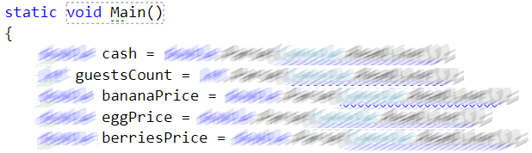
Calculate the Number of Portions
To calculate the number of portions we need to divide the number of guests to 6 and round up to the nearest integer.
Calculate the Needed Money
To calculate needed money for the desserts with the formula
Needed money for 1 product = number of portions * quantity needed * price of the product
We calculate that for all the 3 products and add their values.
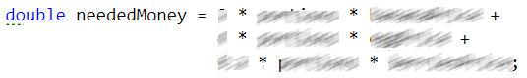
Make a Decision
If the needed money is less or equal to the money Ivancho has we print that Ivancho has enough money otherwise we print the amount of money Ivancho need to buy products for the desert. Rounded 2 digits after the floating point.
